Walk 40 Dymock and Ryton
Last walked in July 2018

Description. 10 km (6.2 mile) walk along The Poets’ Paths, with crop, pasture, woodland edges, nature reserves, and daffodils. (Hereford Times 2015).
Start. Explorer Map 190 Grid 702313.
Directions from Whitecross Roundabout (Turn milometer to zero). Take the A4110 Canon Pyne (Three Elms road) for 1 mile and TR at the traffic lights onto the A4103 Worcester (Roman road). After 7.7 miles TR, signposted to Stoke Edith. After 9 miles TL at the T-junction (not sign posted) onto main road to Ledbury. Reach roundabout at 15.9 miles and turn R for ‘All Other Traffic. At the next roundabout at 16.4 miles continue on the ‘Thru Traffic. 16.9 miles is the next roundabout keep to ‘All thru Traffic. Next roundabout at 17.1 miles you via R and head along the B4216 for Dymock. At 20.9 miles you reach a T-junction, The Beauchamp Arms is on your R. Park in the field across the road from The Beauchamp Arms, (you might want to check with the pub that its OK to park there).

1. Dymock. Walk back along the road you have just arrived on, the B4216 to Ledbury. Cross a road bridge over the River Leadon (Long Bridge). After 100m you TR (Poets’ Path No. 1) and go thru a small metal gate into F1. Go straight across and over a stile into F2. Go straight across to reach the end of a hedge (L), and go into F3, where you angle slightly L to go thru a kissing gate, down 5 steps and onto a road.

2. Elmbridge Villas. Bear L and continue along the road for a few hundred meters, passing the sign posted Vellmill Meadow Nature Reserve (R). 50m past the meadow you TR, walk a few paces and TL to cross a stile into a small field F4. TR, walk thru the field to go thru a gate that’s to the L of the house, and into F5. After 25m you TL over a footbridge into F6. Bear R, cross this field to cross over another footbridge into F7. Cross F7 to go thru a k/gate, and into F8. The River Leadon is on your R and the fence on your L as you walk straight ahead, to cross a stile into F9. Continue in the same direction and in the bottom R corner you cross over a footbridge and under the motorway. Go over another footbridge into F10. Bear L, cross this field to cross over a footbridge into F11. Bear L and head towards the R edge of the farm in front, to reach a marker post near a gate.

3. Callow Farm. Do not go thru the gate but TL and walk along R field edge/near side of fence, and thru gate gap into F12. Continue along R field edge to cross stiles ahead either side of a drive and into F13. Keep ahead on upper R edge of a vast field, heading towards the next motorway bridge. At end of field you TR and walk along a stretch of enclosed hedged grassy field to go thru a k/gate/gate onto a road. TR, carry on up the road to reach a T-junction. TL for Rytron. When you reach a cream coloured house call The Smithy (L), TR and walk up an enclosed public footpath, (PP1). Follow bridle path on edge of Ryton Firs for a kilometer. At bottom of dip you go thru gate and onto track junction.

4. Track Junction. TR, go thru gap into F14, follow track to go sharply back up bank to the R. After 100m, and before the track bends sharply L, you bear R off the drive and cross a stile into trees. Follow woodland edge for a kilometer, going over a stile and thru a wooden gate, trees now up to the L and fence is R. The track bends R and the path now heads for the L side of Farm buildings, to go thru the buildings of Ketford Farm. At far end you TL thru a small metal gate into F15. Walk above a ditch and follow L edge of field, down to reach a bridle crosspatch at the field end. TR, walk along path to go thru a gate/cattle grid and onto a road. TL, walk along the road, crossing over the River Leadon at Ketford. As soon as you cross the river TR and continue along PP1 bridleway. Before reaching the gate in front, labeled Barn Farm, you TR and go thru a metal gate and along an enclosed grassy bridleway that bends L, and goes to the R of a white house. Go up bank, and continue along enclosed bridleway.

5. Ketford Bank Nature Reserve. Go thru small metal gate and continue along an enclosed track. Go thru small metal gate and pass nature reserve board (R) and thru small wooden gate into F16. Follow L f/edge, go thru small gate into F17 and continue along L f/edge and enclosed straight path back over M50. Further along the path turns into tarmac and you continue on, for a kilometer to reach a T-junction. Go straight across, up steps and thru a k/gate into F18. Bear slightly L to cross the field and reach a fence corner, TL thru a k/gate into F19. TR, walk along R field edge and on thru Dymock Cricket Ground. At the far end you go thru metal k/gate into F20. Straight on across, and bend round to the L, to go thru k/gate onto a road. Cross the road and TR and walk up pavement to the start.
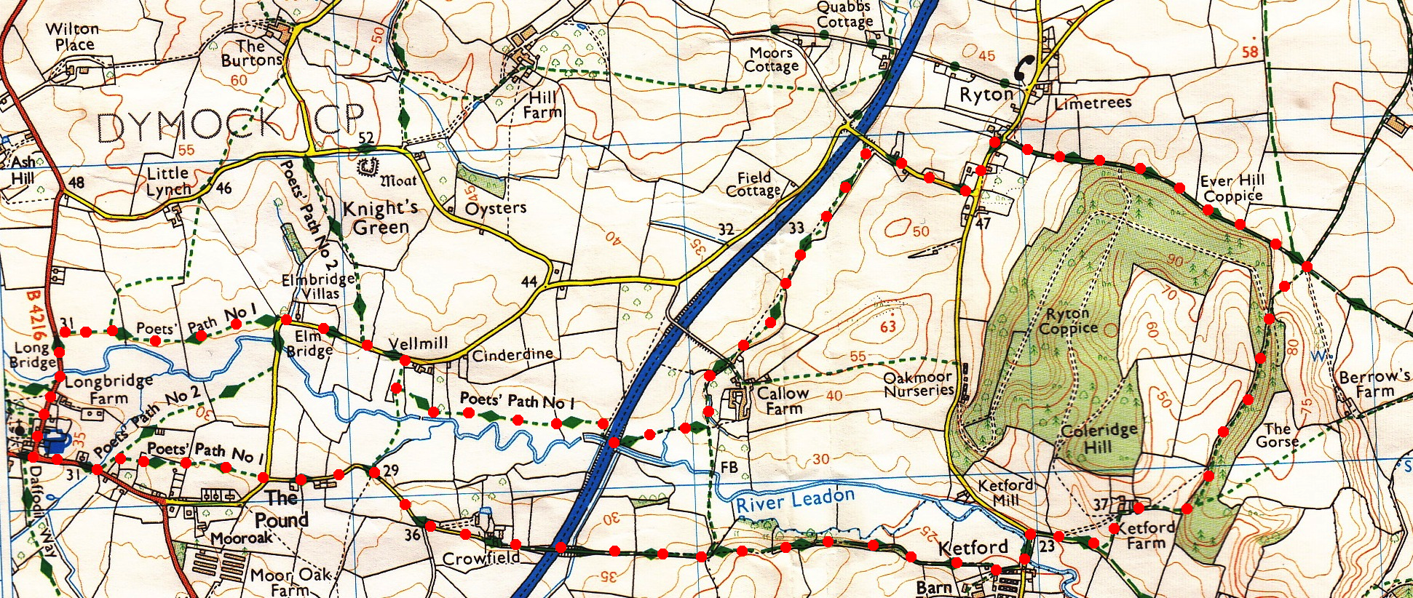
4
2
5
3
1

